NEWS PAPER

* The times of india

Education is one of the fundamental rights of every human being. It's an essential tool for personal and social development, and it's a key factor in breaking the cycle of poverty. However, the cost of E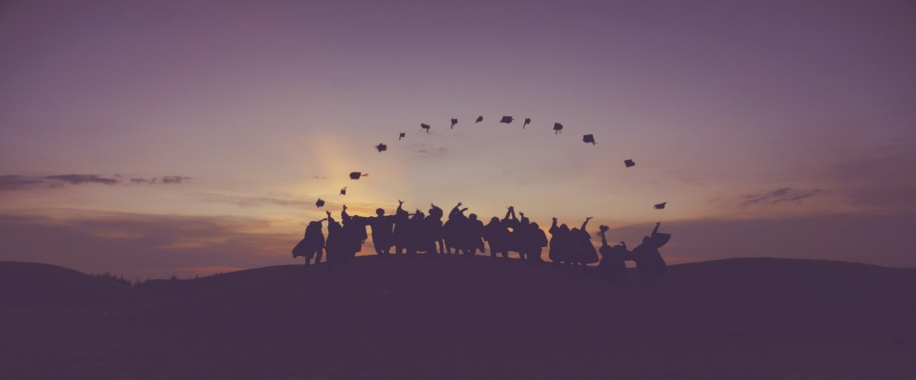

Education has become increasingly expensive, making it inaccessible for many individuals and families. This article will discuss the importance of affordable education and why it should be free.

“Live as if you were to die tomorrow. Learn as if you were to live forever.” ― [**Mahatma Gandhi**](https://www.linkedin.com/redir/redirect?url=https%3A%2F%2Feverydaypower%2Ecom%2Fmahatma-gandhi-quotes%2F&urlhash=kPgY&trk=article-ssr-frontend-pulse_little-text-block)

1. Education is a Basic Human Right

Education is a fundamental human right that should be available to everyone, regardless of their socioeconomic status. Quality education can help individuals break free from the cycle of poverty and achieve their full potential. Education is also crucial for personal and social development, as it helps individuals develop critical thinking, problem-solving, and communication skills.

2. Education Drives Economic Growth

Affordable education is essential for economic growth and development. Education can help individuals develop the skills and knowledge needed to create and innovate, drive technological advancements, and develop sustainable solutions. A well-educated workforce can also attract businesses and investments, creating job opportunities and driving economic growth.

Education can play a critical role in promoting social equality. It can provide individuals from disadvantaged backgrounds with the opportunity to gain the skills and knowledge they need to succeed. When education is accessible to everyone, it can help break down social and economic barriers and create a more equal and just society.

4. Education Benefits Society as a Whole

The benefits of education extend beyond the individual level. A well-educated society can lead to better health outcomes, reduced crime rates, and a more engaged and informed citizenry. Education can also lead to increased civic participation and promote democratic values.

5. The Cost of Education is a Barrier to Access

The high cost of education is a significant barrier to access for many individuals and families. Rising tuition fees, expensive textbooks, and the cost of living can make it impossible for many students to attend college or university. This can create a vicious cycle of debt and financial hardship, limiting opportunities for personal and social development.

In conclusion, education should be free and accessible to everyone. Quality education is a basic human right that can drive economic growth, promote social equality, and benefit society as a whole. When education is affordable, it can help break down barriers and create opportunities for all individuals to achieve their full potential. By investing in education, we can create a more equitable and just society for future generations.

VVVVVVVVVVVVVVVVVV